**Tutorial 02 – Build WordPress CMS on Multiple Platforms and Extend using Best Practices**

Students are required to have access to a Web Host account that they use to create and manage multiple CMS websites. In our first IT320 class we purchased a Shared Web Host cPanel or registered for a Pantheon (PaaS) and Codeanywhere web host accounts. In this assignment, you will record information about these accounts and use them to create your WordPress CMS sites.   
Additionally, we will do a few PHP problems, to test your understanding of the PHP material we covered in class.   
If you have difficulties completing this assignment, please inform the instructor and consider working with DePaul tutors.

**Instructions for completing template:***Replace* **[bracketed red text]** *with the requested information and change the* ***red text to black text.*** *Do not include full screen shot images, or full screen shots that are reduced in size. Use a snippet tool to capture parts of the screen a nd insert those images into the template.  
Please answer all questions.***Please do not alter template numbering.  
Each answer and screen capture are worth points. There are 32 total answers for100 points.**

**PART A – Getting started Student Contact Information**

**1. Student Name: [STUDENT NAME – Aamir, Patel] [A01](1)**

**2. Student Contact Information:   
[Student Preferred Email – Aamir8567@gmail.com] [A02] (2)  
[Student Phone Number – (872) 985 - 4361] [A03] (3)**

**Go back to the tutorial instructions and begin working on part B.**

**Part B – Create a WordPress site on a shared web host**

1. Enter the following shared web host WordPress site information **[B.1]**
   1. Shared Web Host Company Info:Shared Web Host Name**: [ Namecheap] (4.1)**  
      Shared Web Host URL: **[ namecheap.com ]** **(4.2)**Shared Web Host Account Username: **[ aamir8567 ] (5)**  
      Shared Web Host Account Password: **[ Kamboli1! ] (6)**
   2. In Directory Name: [ **mod2tutorial2**] **(7)**
   3. Website Admin Username: **[ aapadcpate] (8)**
   4. Website Admin Password: **[ 9aIwR@LZB%#uk9Fgh3] (9)**
   5. Database Name: **[ wp369]** **(10)**
   6. Table Prefix: **[ wp19\_] (11)**

**Please make sure all B.2 screen capture includes the web browser address bar. [B.2]**

1. Take screen captures of the front end client facing WordPress site **[B.2.1]  
   [** 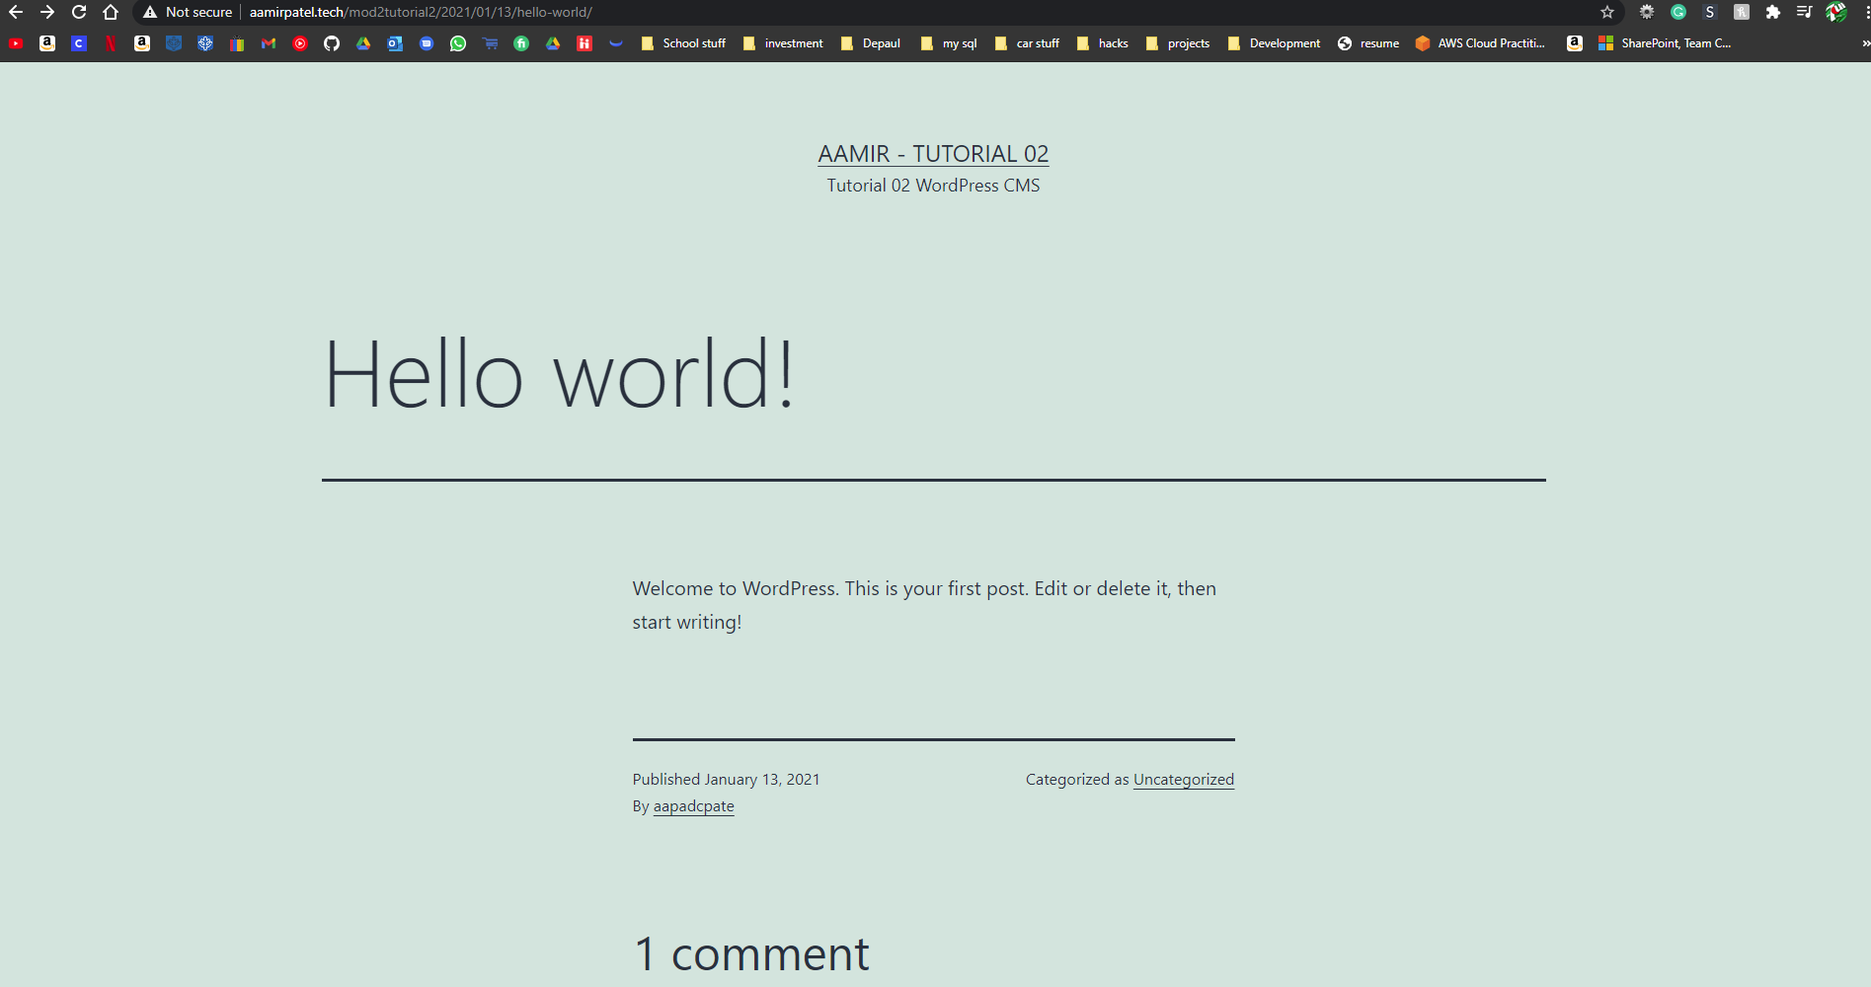**] (12)**
2. Take screen captures of the backend administrative WordPress site   
   select the Dashboard > Home please make sure the “At a Glance” panel is visible.  
   **[B.2.2]  
   [** 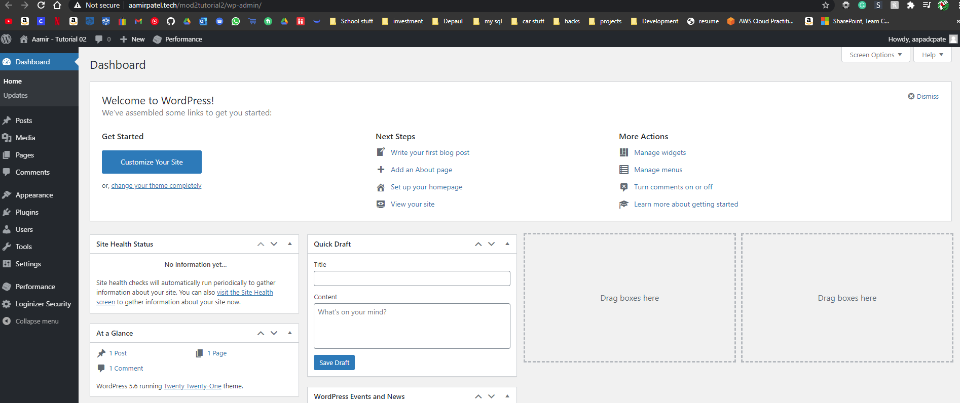**] (13)**

**Go back to the tutorial instructions and begin working on part C.**

**Part C – Create a WordPress site on Pantheon (PaaS)**

1. Enter the following shared web host WordPress site information **[C.1]**
   1. PaaS WordPress site Admin Username: **[ N/A]**
   2. PaaS WordPress site Admin Password: **[ N/A ]**

**Please make sure all C.2 screen capture includes the web browser address bar. [C.2]**

1. Take screen captures of the front-end client facing WordPress site **[C.2.1]  
   [ N/A]**
2. Take screen captures of the backend administrative WordPress site,   
   select the Dashboard > Home with the “At a Glance” section visible **[C.2.2]  
   [ N/A]**

**Go back to the instructions and begin working on part D.**

**Part D – Create a WordPress site on Codeanywhere**

1. Enter the following Codeanywhere web host WordPress site information **[D.1]**
   1. Site Title: **[ AP - Tutorial 02 CA] (14)**
   2. Username: **[ mapjkam] (15)**
   3. Password: **[ EJrsHR3TNa2SVfsl$21asfvcxzc] (16)**
   4. Your Email: **[ mpate180@depaul.edu] (17)**

**Please make sure all D.2 screen capture includes the web browser address bar. [D.2]**

1. Take screen captures of the front end client facing WordPress site **[D.2.1]  
   [** 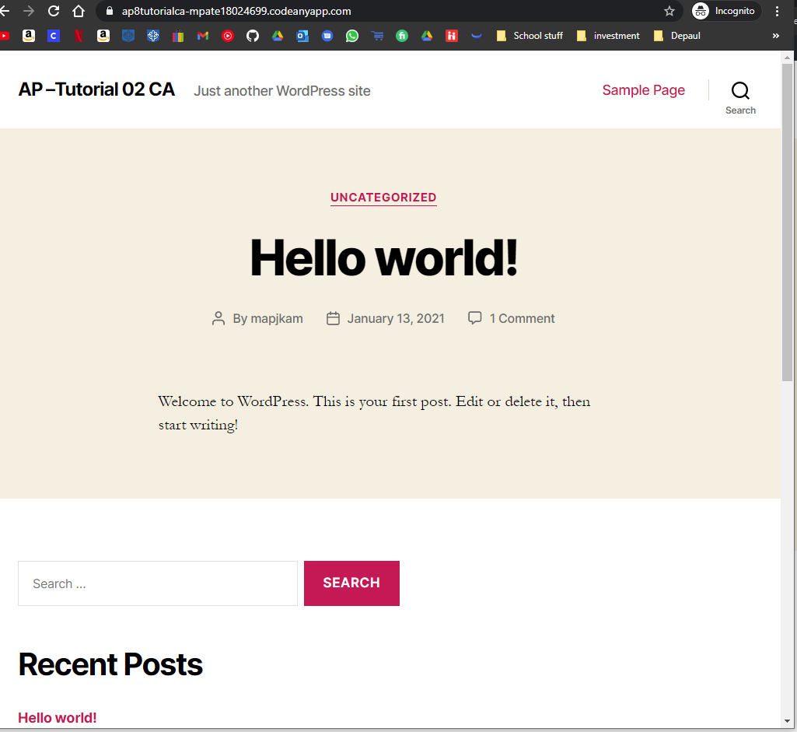**] (18)**
2. Take screen captures of the backend administrative WordPress site   
   select the Dashboard > Home

NOTE – Please look at the screen capture you took.

Look at the “AT A GLANCE “ section.   
Does it say WordPress version 5.# running “Twenty Twenty” THEME?  
Where 5.#, the # is a number. Example 5.4 was around April 2020   
**IF NOT THEN you did not follow instructions** and upgrade the WordPress version and change the active theme. Please do so now AND TAKE and post A NEW SCREEN CAPTURE!  
**[D.2.2]  
[** 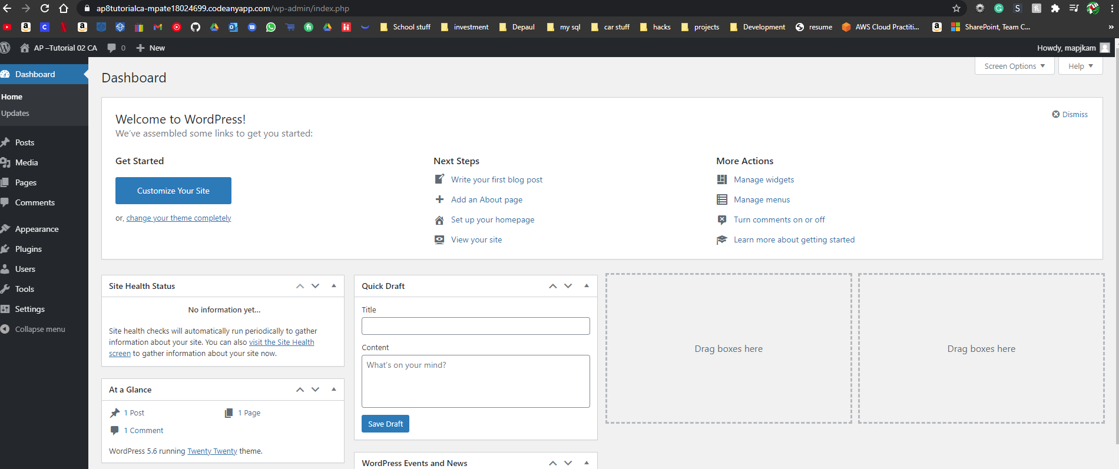**] (19)**

**Go back to the instructions and continue at Part E.**

**Part E – Introduction to Best Practices**

1. You are looking for a form plugin.   
   [Do not find this plugin on a WordPress site marketplace.   
   Use the image below to review WordPress plugin selection best practices.]  
   The following (see image below) plugin came up while searching the WordPress plugins page. Examine the following WordPress plugin. List your reasons and the best practices you used to make your decision of whether this plugin should be installed on your website and activated and used.  
   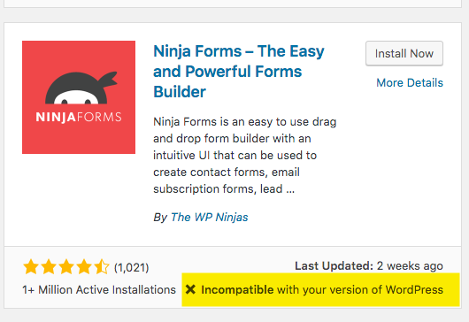  
     
   **[ I would not select this plugin because it is not compatible with my version of WordPress. I would consider this plugin if it was compatible, because it meets the other requirements such as consistent updates, good amount of installation, and good reviews.] [E.1] (20)**
2. You are looking for a form plugin.   
   [Do not find this on a WordPress site. Use the image below to review WordPress plugin selection best practices.]  
   The following (see image below) plugin came up while searching the WordPress plugins page. Examine the following WordPress plugin. List your reasons and the best practices you used to make your decision of whether this plugin should be installed on your website and activated and used.  
   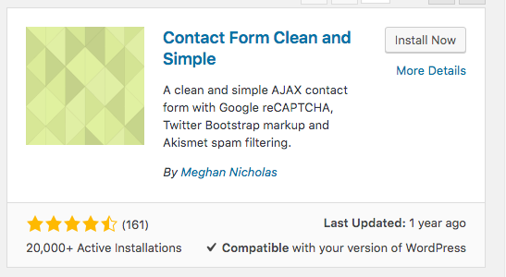  
     
   **[ I would not select this plugin for my app because it does not update as often as it should. Not updating the plugin could mean the developers have stopped developing this plugin and maybe it would not be supported in the next version of WordPress.] [E.2] (21)**
3. You are looking for a meeting tool plugin.   
   [Do not find this on a WordPress site. Use the image below to review WordPress plugin selection best practices.]  
   The following (see image below) plugin came up while searching the WordPress plugins page.   
   Examine the following WordPress plugin. Answer the questions “what exactly does Untested mean and also list your reasons and the best practices you used to make your decision of whether this plugin should be installed on your website and activated and used.  
   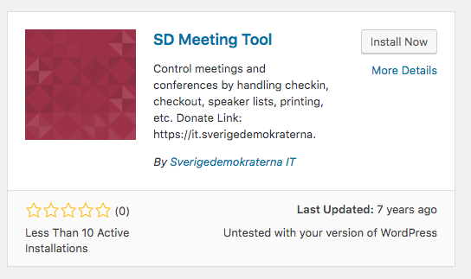  
     
   **[I would not use this because not only this plugin have not been updated in over 7 years, it even has less than 10 active installation which tells me, people are not interested in this plugin. No reviews is also a red flag, not to ignore the biggest factor which is that it haven’t been tested in our WordPress version. Which means the author has not taken its time to update the readme of the application and test it with the new tests that are required in the new version of WordPress.] [E.3] (22)**
4. You are looking for a form plugin.   
   [Do not find this on a WordPress site. Use the image below to review WordPress plugin selection best practices.]  
   The following (see image below) plugin came up while searching the WordPress plugins page. Examine the following WordPress plugin. list your reasons and the best practices you used to make your decision of whether this plugin should be installed on your website and activated and used  
   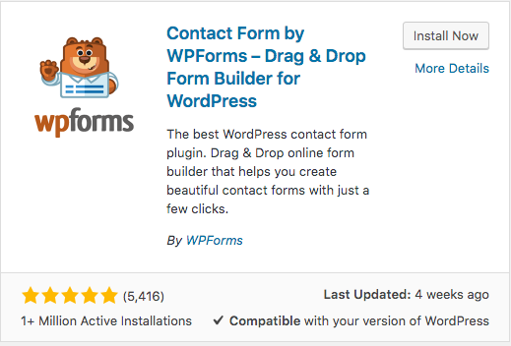  
     
   **[ I would use this plugin with my application, because it meets all the criteria of the best practices. It has more than enough active installations, and reviews. It has been tested and updated to comply with our version of WordPress, and it was updated recently which means that the author is active enough to update the plugin throughout new versions of WordPress, so we can keep using the plugin.] [E.4] (23)**
5. While searching for a Google Map plugin, you find the following 2 plugins. Their names appear to be very similar. **What steps or process or evaluation techniques would you take to determine functional similarities and differences**?

|  |  |
| --- | --- |
| HD:private:var:folders:vh:lbh1qypx7zldldk1l9f6tpsc0000gn:T:2019-12-04_09-37-38.png | HD:private:var:folders:vh:lbh1qypx7zldldk1l9f6tpsc0000gn:T:2019-12-04_09-37-21.png |

**[ I would first start by creating a gap analysis for these plugins, and determine the basics like reviews, update time, compatibily and active users. Whichever seems more popular and better in that section is a good pick. However, if they are both similar in the initial analysis, I would do another gap analysis for the features both offer, and if they both meet my budget for a plugin. After that analysis I would pick the one with better features and fits my budget. An example of Gap analysis is in Fig.1**

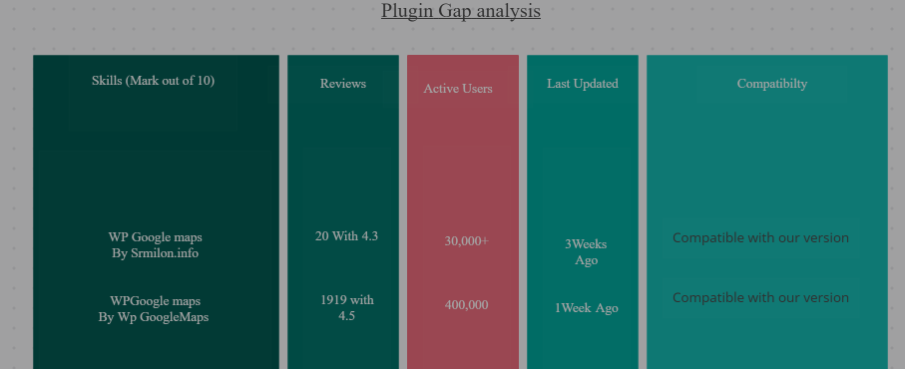**(Fig 1) ] [E.5] (24)**

**Go back to the instructions and continue at Part F.**

**Part F – Extend 1 Platform WordPress site with Images**

**Please make sure all Part F screen capture include the web browser address bar. [F]**

1. Take screen captures of the backend administration WordPress site Dashboard > Media page – with the media library in GRID mode **[F.1]  
   [** 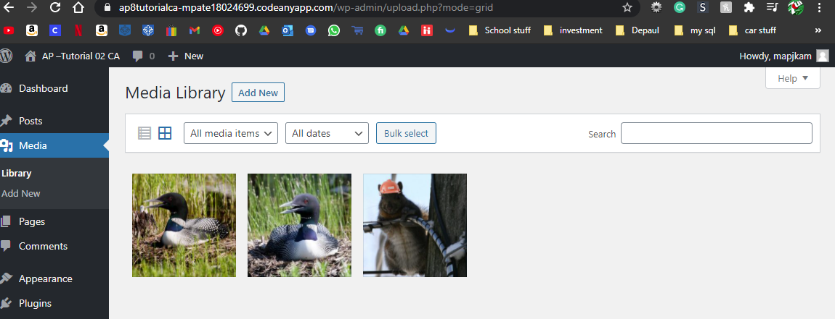**] (25)**
2. Take screen captures of the backend administration WordPress site Dashboard > Media page – with the media library in LIST mode **[F.2]  
   [** 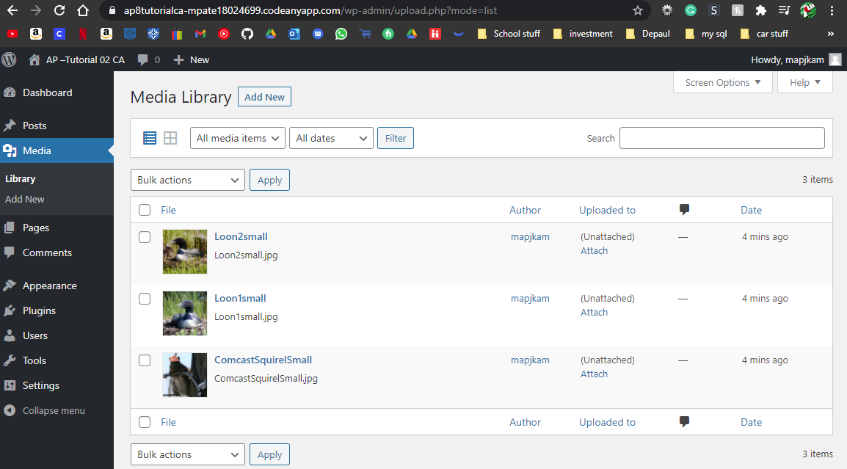**] (26)**

**Go back to the instructions and continue at Part G.**

**Part G – Extend 1 Platform WordPress site with Menus**

**Please make sure all Part G screen capture include the web browser address bar. [G]**

1. Take screen captures of the backend administration WordPress site Dashboard > Menu page – please make sure the menu Structure and Menu Settings sections are captured **[G.1]  
   [** 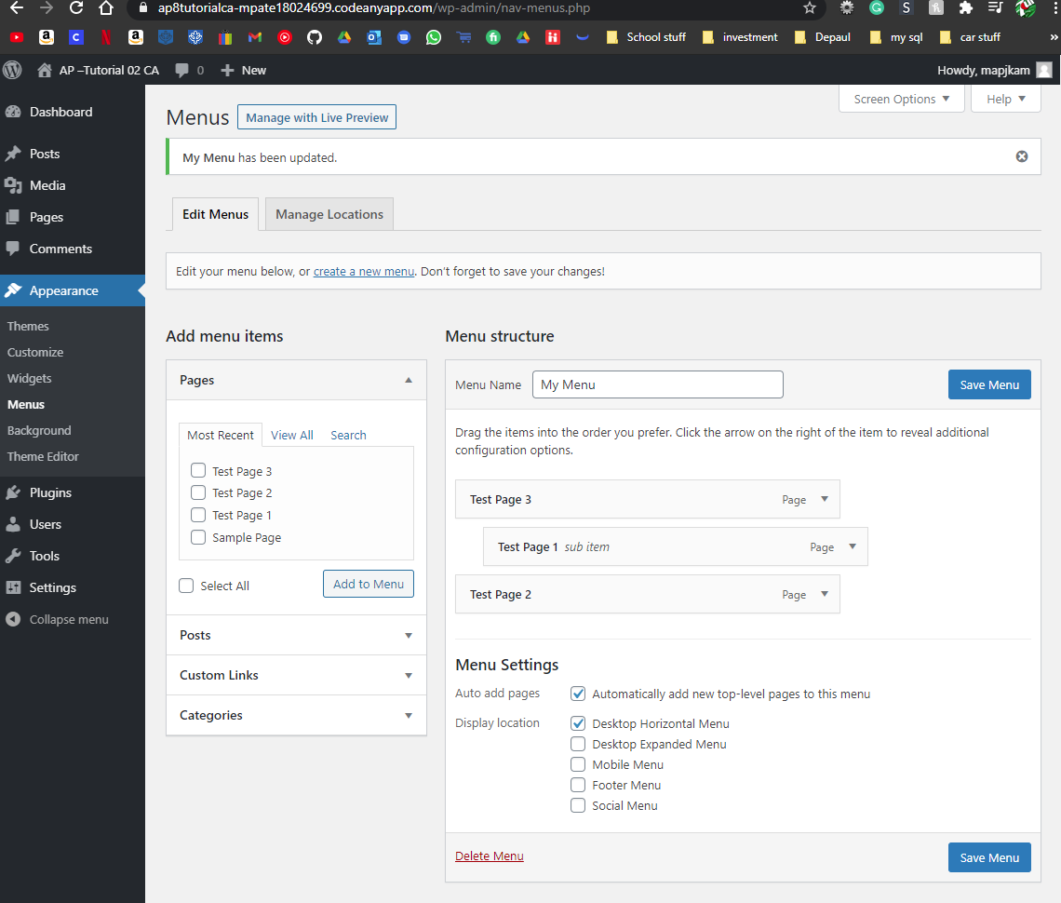**] (27)**
2. Take screen captures of the front-end client facing WordPress site showing the menu items on the home page **[G.2]  
   [** 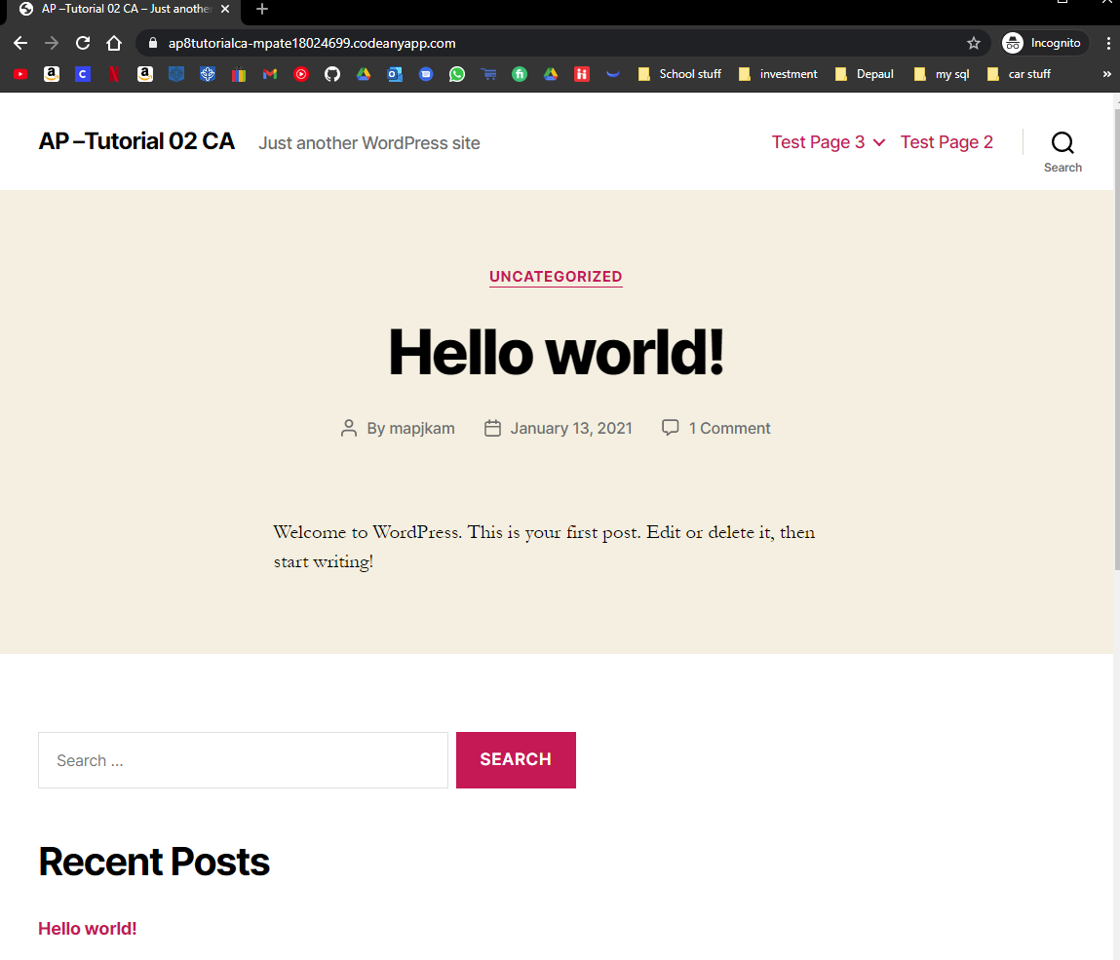**] (28)**

**Go back to the instructions and continue at Part H.**

**Part H – PHP QUESTIONS**

**Testing PHP Programs using PHP Emulation Websites:**

Online PHP test sites:

<http://phptester.net>

<http://www.writephponline.com/>

<http://sandbox.onlinephpfunctions.com/>

<https://wtools.io/php-sandbox>

How you test your script depends on which test site you use.

**Each PHP emulation test site works slightly different**.

Please read the site instructions before testing your PHP code.

1. Write PHP that does the following: **(29)**
   1. Creates 4 variables, with values 1,2,3, and 4
   2. Use an arithmetic operator to add the four variables together and assign the result to a 5th variable named $result.
   3. Display the $result value using an echo statement.

**Test your code using an online PHP test site and paste the code and results in the table cell below.**

|  |
| --- |
| Copy and paste the code block and record the results on the next row. A screen shot from the PHP test site will be the best way to not affect template format. Please try not to change the template numbering or format. |
|  |

1. Write PHP that does the following: **(30)**
   1. Creates 3 variables, with values “xxx”, “zzz”, and “qqq”.
   2. Concatenate all three variables adding a space between each one and assign the result of the concatenation into a 4th variable named $result.
   3. Display the $result value using an echo statement.

**Test your code using an online PHP test site and paste the code and results in the table cell below.**

|  |
| --- |
| Copy and paste the code block and record the results on the next row. A screen shot from the PHP test site will be the best way to not affect template format. Please try not to change the template numbering or format. |
| \*\*\*\* |

1. Write PHP that does the following: **(31)**
   1. Creates 2 variables, with values 5 and 10
   2. Write separate lines of code that adds, subtracts, divides, multiplies, and performs a modulus on the 2 variables and displays the result value without an additional variable using an echo statement.

**Test your code using an online PHP test site and paste the code and results in the table cell below.**

|  |
| --- |
| Copy and paste the code block and record the results on the next row. A screen shot from the PHP test site will be the best way to not affect template format. Please try not to change the template numbering or format. |
| \*\*\*\* |

1. Write PHP that does the following: **(32)**
   1. Creates 4 variables, with values “My”, “Name”, “is”, “Your Last Name”
      * Use your actual last name for the Your Name variable
   2. Write PHP code that displays each variable on a separate line of using the HTML break or paragraph TAG

**Test your code using an online PHP test site and paste the code and results in the table cell below.**

|  |
| --- |
| Copy and paste the code block and record the results on the next row. A screen shot from the PHP test site will be the best way to not affect template format. Please try not to change the template numbering or format. |
| \*\*\*\* |

1. Write PHP that does the following: **(33)**
   1. Creates 4 variables, with values “My”, “Name”, “is”, “Your Name”
      * Use your actual name for the Your Name variable
   2. Write PHP code that displays the variables in an HTML 4 row TABLE with a border value of 1.

**Test your code using an online PHP test site and paste the code and results in the table cell below.**

|  |
| --- |
| Copy and paste the code block and record the results on the next row. A screen shot from the PHP test site will be the best way to not affect template format. Please try not to change the template numbering or format. |
| \*\*\*\* |

Part H is the last part of this tutorial.   
After finishing the PHP, review your template file and submit it to D2L. You can then start the Assignment. You will need to delete your Codeanywhere container to do the assignment.

**Questions or problems with this tutorial?   
If you have questions or issues about this tutorial please contact the instructor immediately.**

**To get help, either submit an IRT, or make an appointment with the DePaul tutor or connect to BlueStar and make an appointment for an office hours appointment for help.  
If you find errors with this tutorial, please fill out a BRECT form and submit it to the instructor ASAP for Extra Credit points.**

Michael H Chase

Mobile: 847-878-6225

Office: 312-362-1352

Email: [mchase2@cdm.depaul.edu](mailto:mchase2@cdm.depaul.edu)

Submit your completed tutorial template to D2L dropbox for the current weeks tutorial.

If you prefer not to navigate by hand to the D2L dropbox, take advantage of the dropbox link in

the current D2L Module Tutorial section. The D2L link will take you to the correct tutorial dropbox location.